DEPARTMENT OF ELECTRICAL ENGINEERING
COEP Technological University


Control System Engineering Lab 3

To study the effect of change in open loop gain on open loop and closed loop system performance.

MIS Number: 612205039

Name: Parth Madan Motre
Performance Date:
Grade:

EXPERIMENT NUMBER :- 3

AIM:
To study the effect of change in open loop gain on open loop and closed loop system performance.
SOFTWARE: MATLAB, Simulink.

PROCEDURE:
Part A: MATLAB program
- Write the program for open loop first order system with variable gain in MATLAB editor window.
- Change the value of gain K in the program.
- Run the program to observe output response.
- Write a program for closed loop first order system for different open loop gain(k=1,5,10).
- Run the program to observe output response for each gain.
- Repeat the above procedure for open loop second order system.
- Add a feedback command to create a closed loop second order system with variable gain.
- Run the program and observe the results.
Part B: Simulink model
- Create a block diagram for open loop first order system with a variable gain block.
- Change the gain value and observe the output response using the scope.
- Add a feedback path to make it a closed loop first order system and observe the output response for different gain values.
- Similarly create a closed loop second order system with variable gain.
- Run the simulation and observe the results and compare them with the results obtained through the MATLAB program.

Date: 27-1-2025
MATLAB Program:
First order open loop system

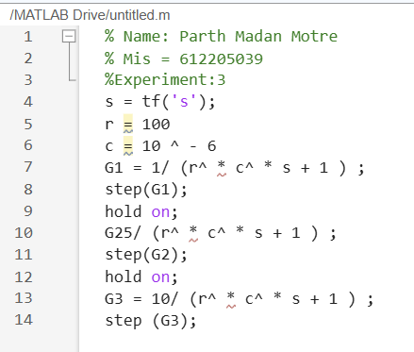

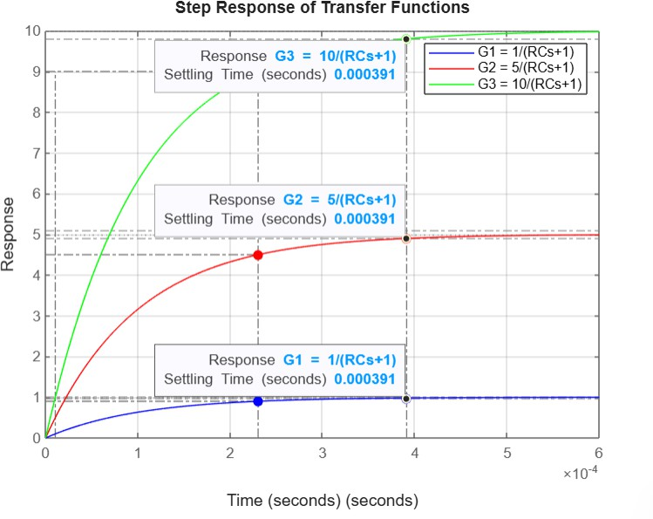
612205070

DISCUSSION ON ABOVE RESULT/PLOT:
The open-loop first-order system shows a direct relationship between gain and system response. As the gain increases, the system output follows the input more aggressively but lacks correction for disturbances, leading to steady-state errors.

1)First order closed loop system
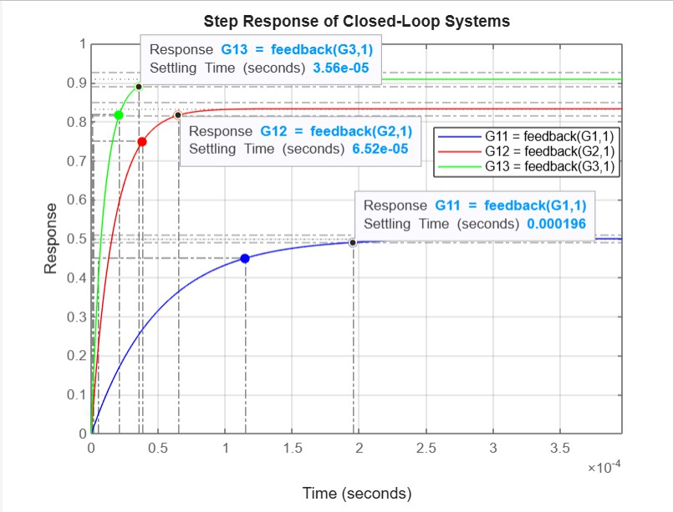
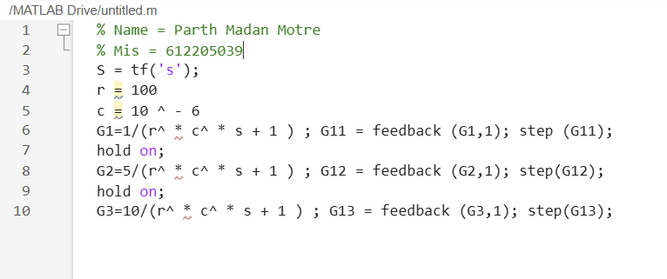
612205039

DISCUSSION ON ABOVE RESULT/PLOT:
With feedback, the first-order closed-loop system demonstrates improved stability and reduced steady-state error. Higher gain results in a faster response and shorter settling time while maintaining system accuracy.
- 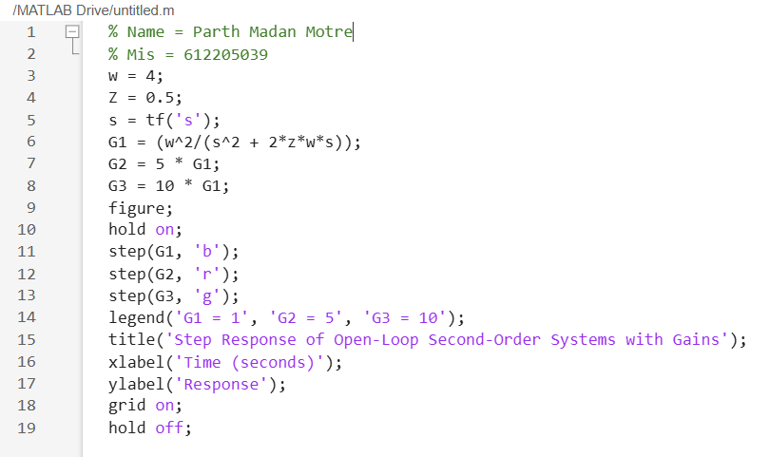
- Second order open loop system

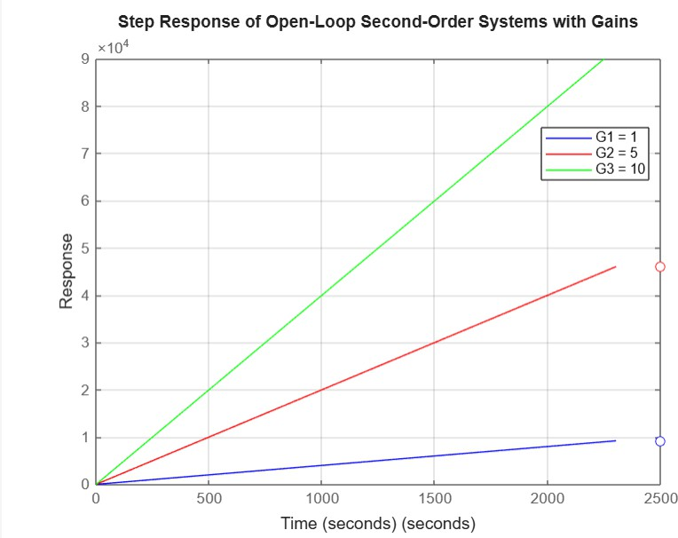
612205070

DISCUSSION ON ABOVE RESULT/PLOT:
The open-loop second-order system exhibits oscillatory behavior, with response characteristics highly dependent on system parameters. Without feedback, it may not settle or take an infinite time to reach steady-state, leading to instability in certain cases.

- 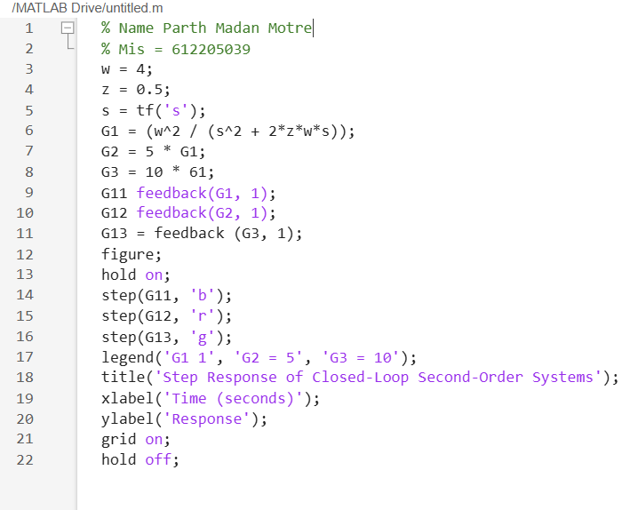
- Second order closed loop system:

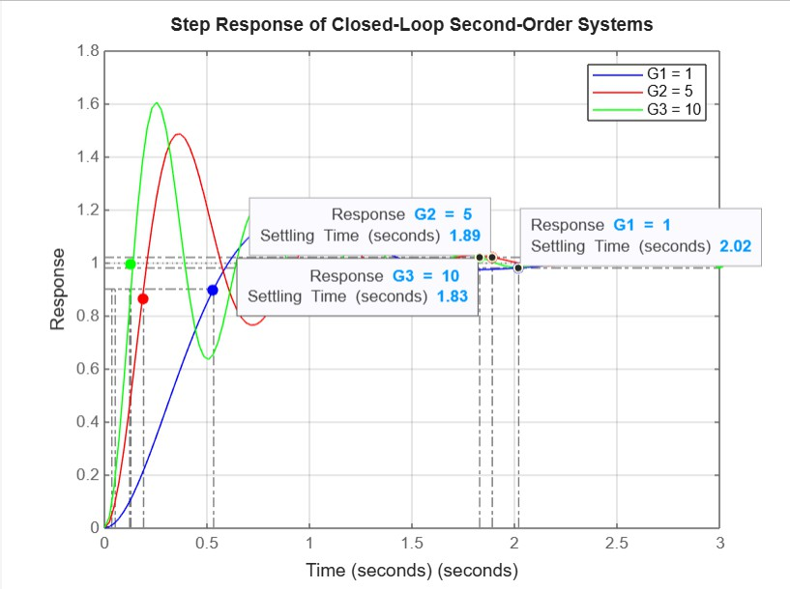
612205070

DISCUSSION ON ABOVE RESULT/PLOT:
The closed-loop second-order system shows improved performance with better damping. As gain increases, the system becomes more responsive but at the cost of increased overshoot and oscillations before settling. Higher gain reduces settling time but may introduce excessive oscillations.

Simulink Model:
First order open loop system
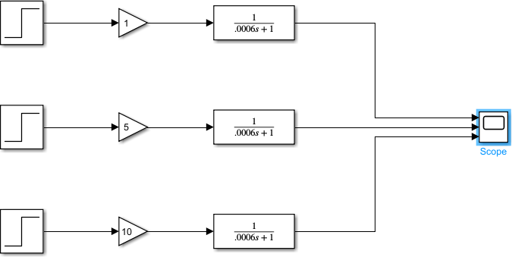
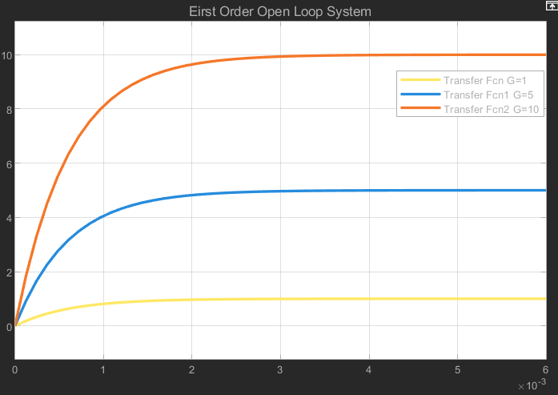
612205039
612205070

DISCUSSION ON ABOVE RESULT/PLOT:

The Simulink model of the first-order open-loop system demonstrates a direct relationship between gain and output response. As the gain increases, the system reaches a higher steady- state value but lacks feedback for error correction, leading to steady-state errors and slow settling.

First order closed loop system
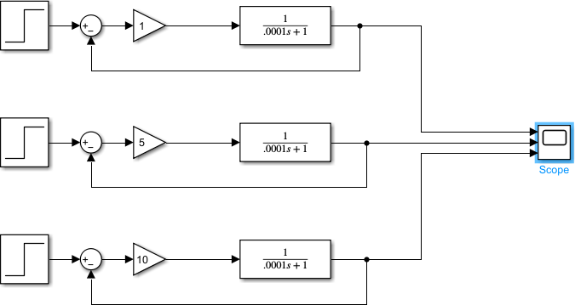
612205039

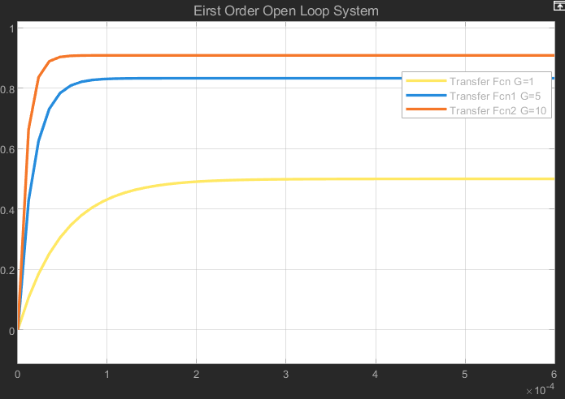
612205070

DISCUSSION ON ABOVE RESULT/PLOT:
With feedback, the first-order closed-loop system achieves a faster response and improved stability. Higher gain results in quicker settling with reduced steady-state error. The system effectively corrects deviations, making it more robust than the open-loop counterpart.

Second Order open loop system
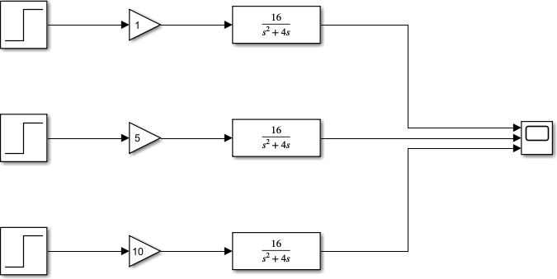
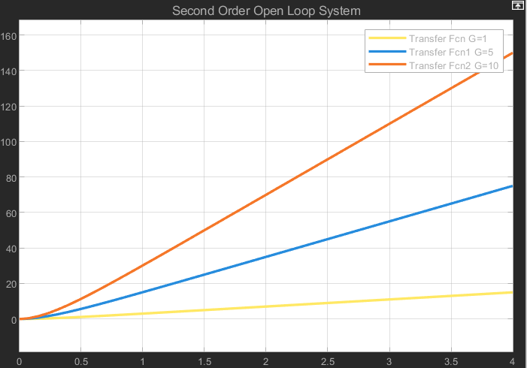
612205070
612205070

DISCUSSION ON ABOVE RESULT/PLOT:
The open-loop second-order system exhibits oscillations and instability in certain cases. Without feedback, the system response heavily depends on the gain, and in some cases, it may not settle at all. The model highlights the lack of damping, which can lead to prolonged oscillations.
Second Order closed loop system
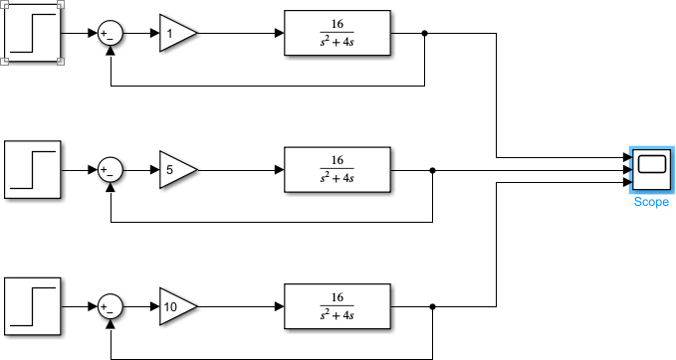
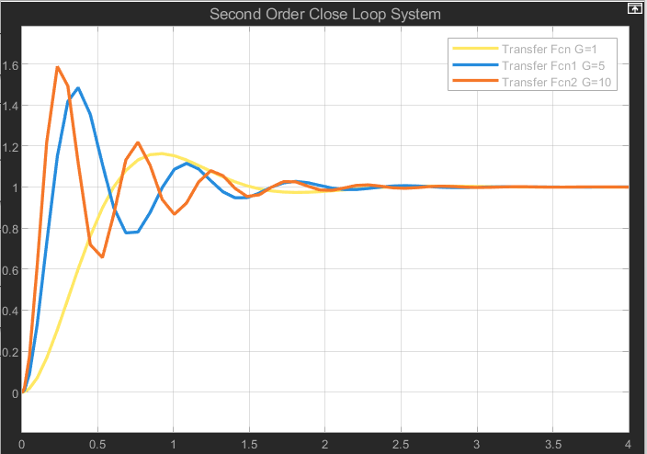
612205070
612205070

DISCUSSION ON ABOVE RESULT/PLOT:
The closed-loop second-order system in Simulink demonstrates improved damping and stability. As gain increases, the response becomes faster, but overshoot and oscillations also increase. A properly tuned gain ensures a balance between quick response and minimal oscillations, confirming theoretical analysis.

Observations:
- First order closed loop system settles at a lower value compared to open loop system.
- First order closed loop system has a faster settling time than open loop system.
- Second order open loop system doesn’t settle or it takes infinite time to settle.
- As the gain increases for a second order closed loop system the maximum peak overshoot increases and the number of oscillations before settling also increases.
- As the gain of closed loop systems increases the settling time reduces.

Conclusion:
We studied the system response of first order and second order systems for different values of open loop gain.

